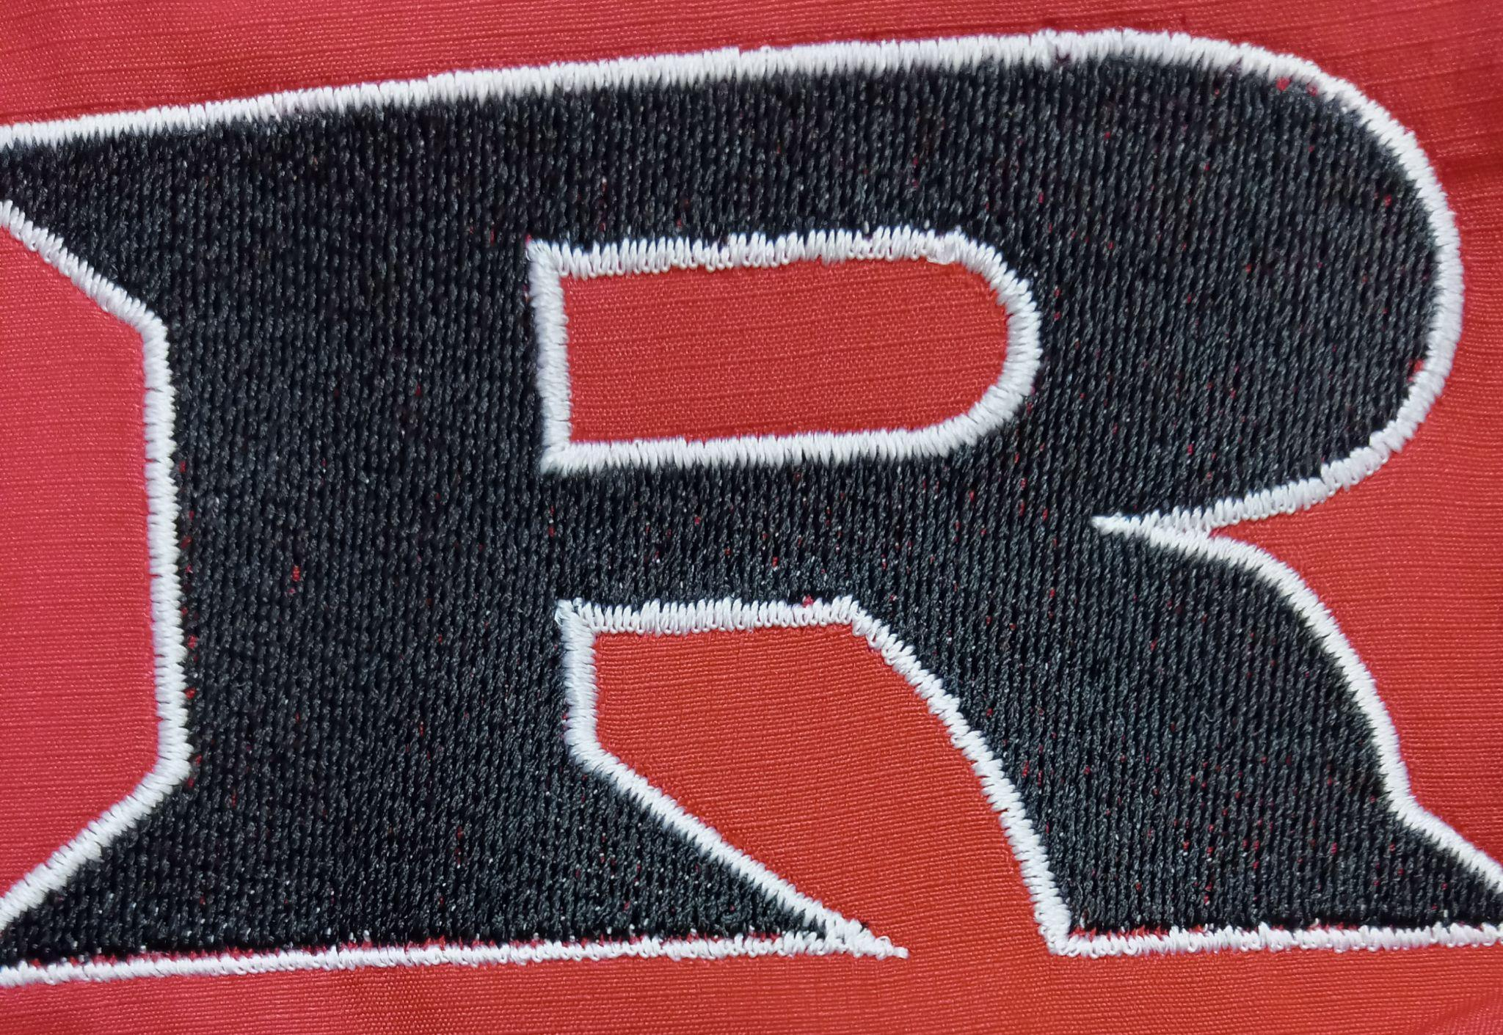

**2025 Varsity Powerlifting Schedule**

**January 9th Ringwood 9:00 AM**

**January 29th Woodward (Girls) 6:00 AM**

**January 31st Woodward (Boys) 6:00 AM**

**February 7th Waukomis 6:00 AM**

**February 19th Wetumpka (8-man State) 6:00 AM**

**February 25th Fairview (Girls Regional) 6:00 AM**

**March 3th Durant (Girls State) 6:00 AM**

**March 7th Enid (Regionals) 6:00 AM**

**March 15th El Reno (State) 6:00 AM**

**Head Coach: Eric Bradley**

**Principal: Kyle Stewart**

**Athletic Director: Amanda Stinnett**

**Superintendent: Wade Detrick**