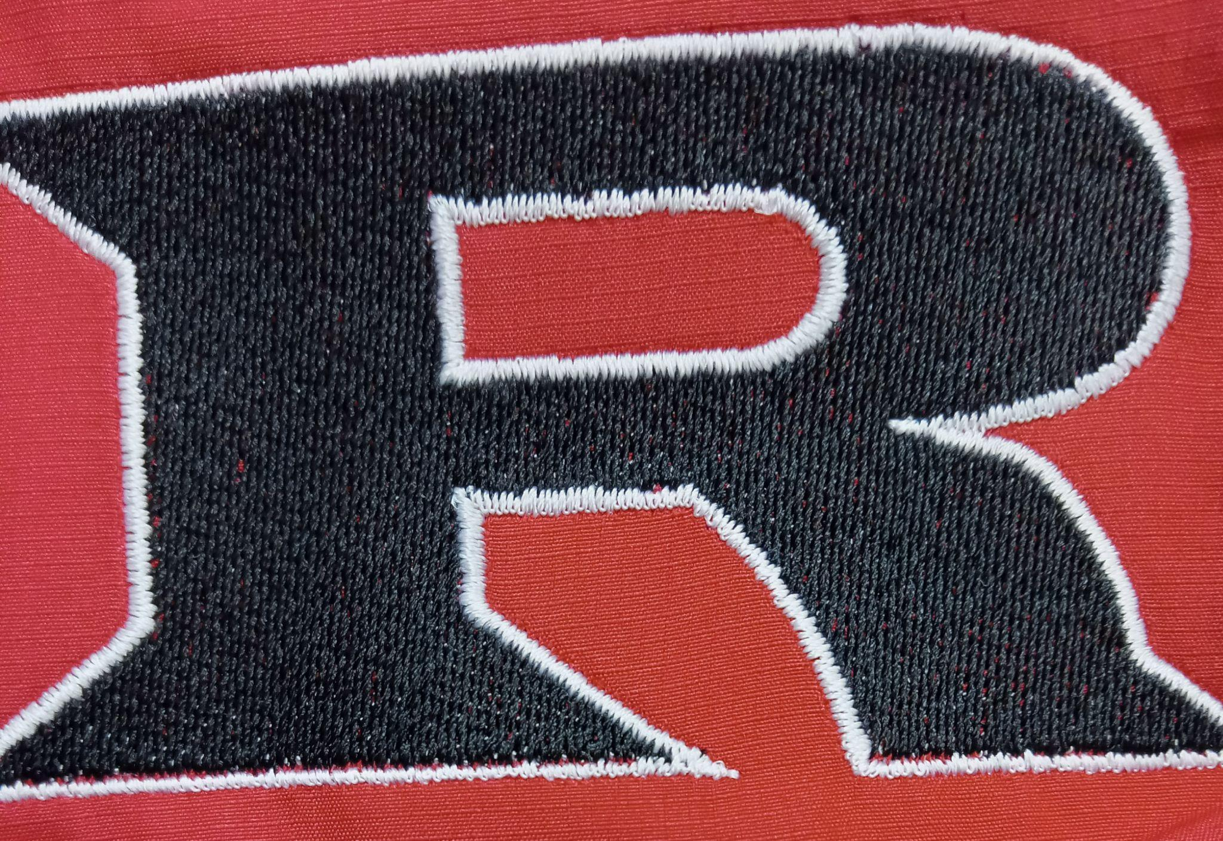

**2025 JH Powerlifting Schedule**

**January 9th Ringwood 9:00 AM**

**January 30th Woodward 6:00 AM**

**February 6th Waukomis 6:00 AM**

**February 18th Wetumpka (8-Man State)6:00 AM**

**March 5th Enid (11-man Regional) 6:00 AM**

**March 13th El Reno (11-man State) 6:00 AM**

**Coach: Eric Bradley**

**Principal: Kyle Stewart**

**Athletic Director: Amanda Stinnett**

**Superintendent: Wade Detrick**