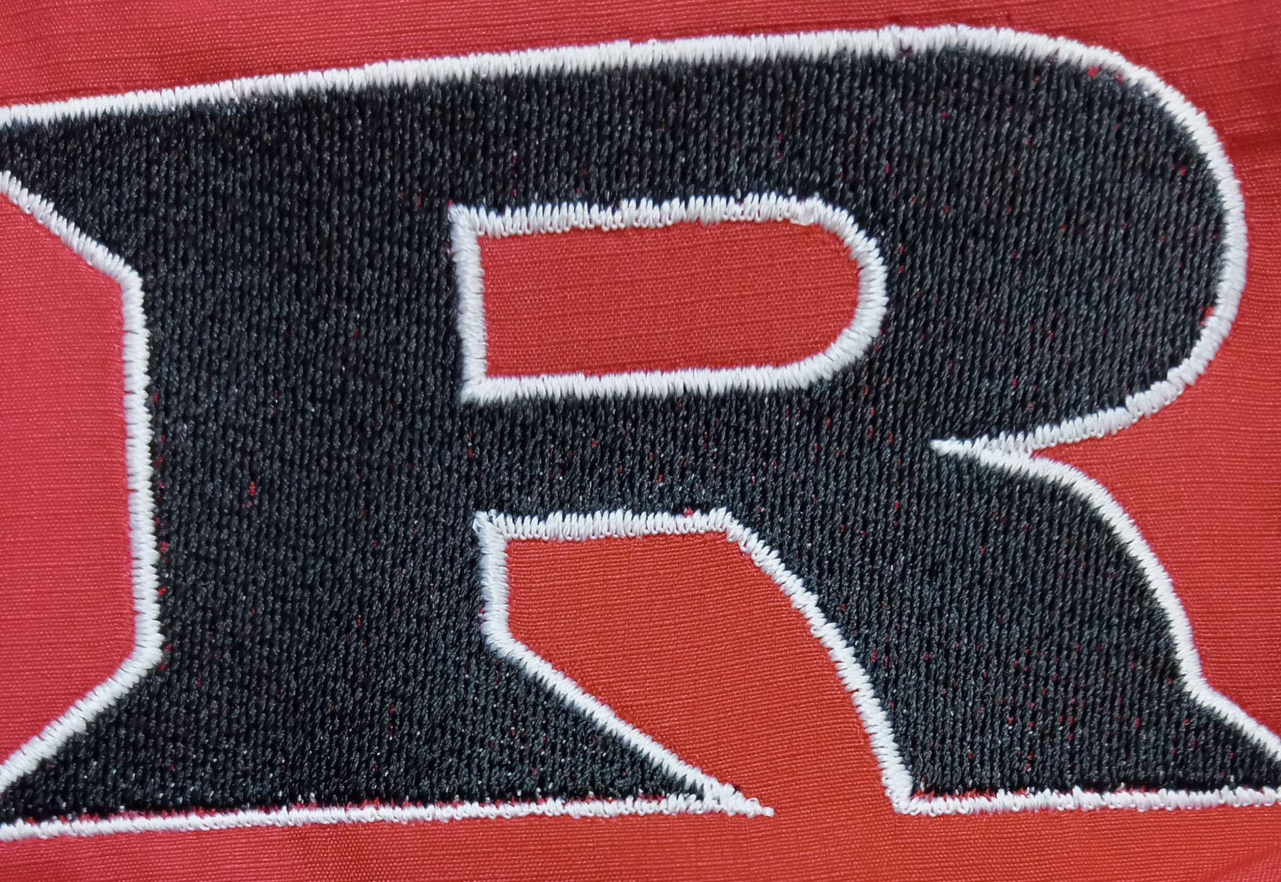

**2024 GS & JH Football Schedule**

Tuesday September 3rd Kremlin Home 5:30/6:30

Monday September 9th Waynoka Home 5:30/6:30

Monday September 16th Garber Home 5:30/6:30

Monday September 23rd Covington Home 5:30/6:30

Monday September 30th Cherokee Home 5:30/6:30

Monday October 7th OBA Away 5:30/6:30

Monday October 14th Timberlake Away 5:30/6:30

Tuesday October 22nd Canton Away 5:30/6:30

**Head Coach: Eric Bradley**

**Principal: Kyle Stewart/Denise Bowers**

**Athletic Director: Amanda Stinnett**

**Superintendent: Wade Detrick**